**Help**

Read Instructions (Event: Click on Read Instructions at the beginning of the game)

If you are new to the game, it is recommended that you read these instructions before proceeding.

**Introduction:**

Guptaji, the owner of grocery store – Meri Dukaan, is going on holiday for 3 months (12 weeks). He has left you in charge! You need to manage and run his store to the best of your ability and better or match his record. You will compete with others and the player that has the highest amount of money at the end of three months wins the game.

As part of running the store you will need to:

-Sell goods to customers

-Keep your inventory updated

-Take decisions that may cause you loss or gain of money and reputation

-Face various lucky and unlucky circumstances

**Set up the game:**

Click on start game. First enter the number of players. Key in the name and select the token for each player.

Each player begins with a bank balance of Rs. 2,00,000 and an inventory level of 60%.

**The Board:**

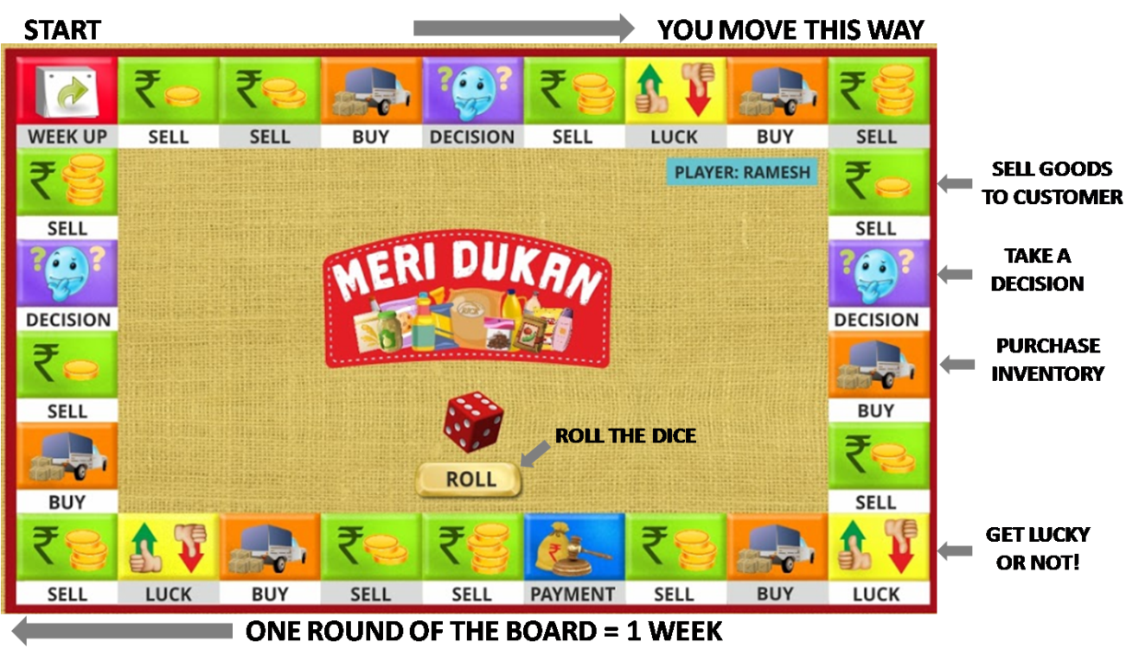

As you move around the board, by rolling the dice, you will land on various spaces. You will have to take action as per the space you have landed on.

**The Information Panel:**

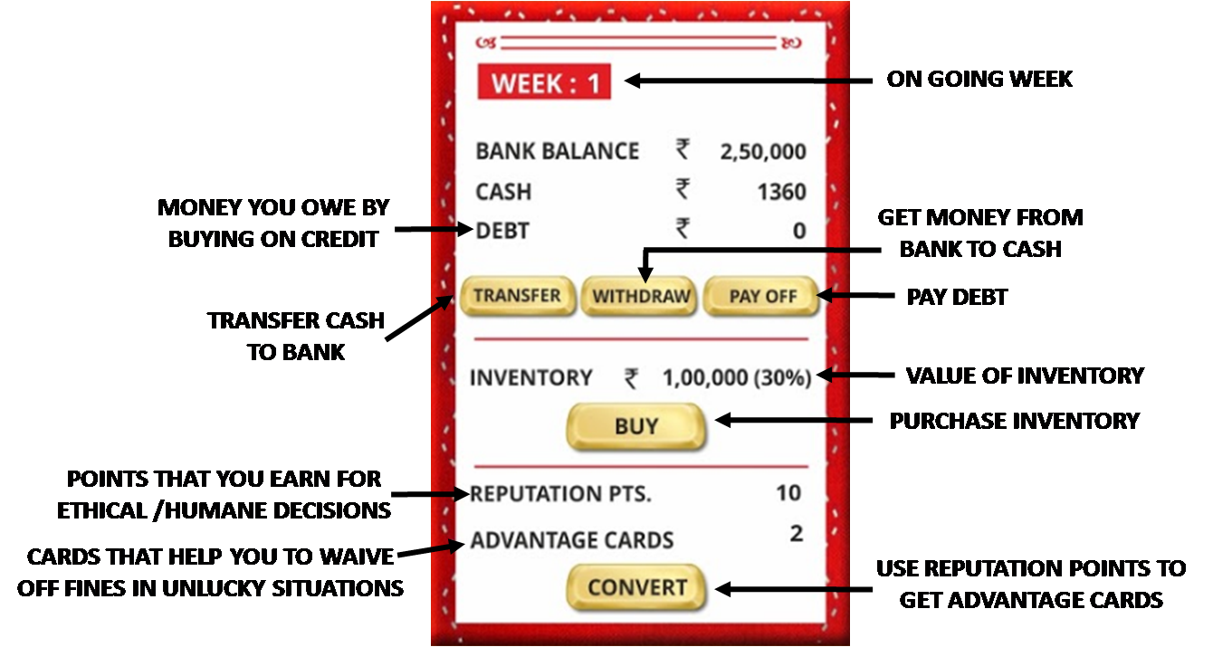

**Bank Balance:** Amount of money in the bank

**Cash:** Amount of cash in hand

**Debt:** Amount owed to wholesaler for purchasing on credit

**Inventory:** Inventory is only visible as a level. Inventory items are not maintained individually. Eg. Inventory Level = 30% indicates that your inventory is 30% full.

**Reputation Points:** Reputation points are those that you earn for taking ethical, humane or kind decisions although they may result in loss of money.

Eg. *You have to shut shop for 2 hours as your friend is ill and you need to take him to the hospital. You will lose business worth Rs. 3500. Will you go?*

If you do choose to go and help your friend, you will lose some money but you will earn reputation points.

**If you accumulate more than 100 reputation points, it means your reputation has spread far and sales will go up significantly.

**Advantage Cards:** You can convert some reputation points to advantage cards. (15 Reputation Points = 1 Reputation Card)

Advantage cards help you to get out of unlucky situations without paying a fine.

**Buttons:**

**Withdraw:** Allows you to withdraw money from the bank and adds it to cash in hand

**Transfer:** Transfers some or all cash in hand to bank. This earns you reputation points as it is a good practice to put extra cash in the bank.

**Pay Debt:** When inventory is purchased on credit, the amount owed shows as Debt.

**Convert:** This allows you to convert reputation points to advantage cards. (15 reputation points gives you 1 Advantage card)

**Playing the game:**

Players play turn by turn. On their turn, players click on ‘Roll’ 

Tokens move ahead by the number of spaces indicated on the dice.

**Landing on spaces:**

**Sales:**

Sales spaces indicate that a customer has come to your store to purchase items. You need to find out what the customer owes you for the items they have purchased. There are different levels of difficulty for this calculation which are indicated by the sales space you land on.

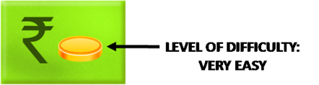 

 

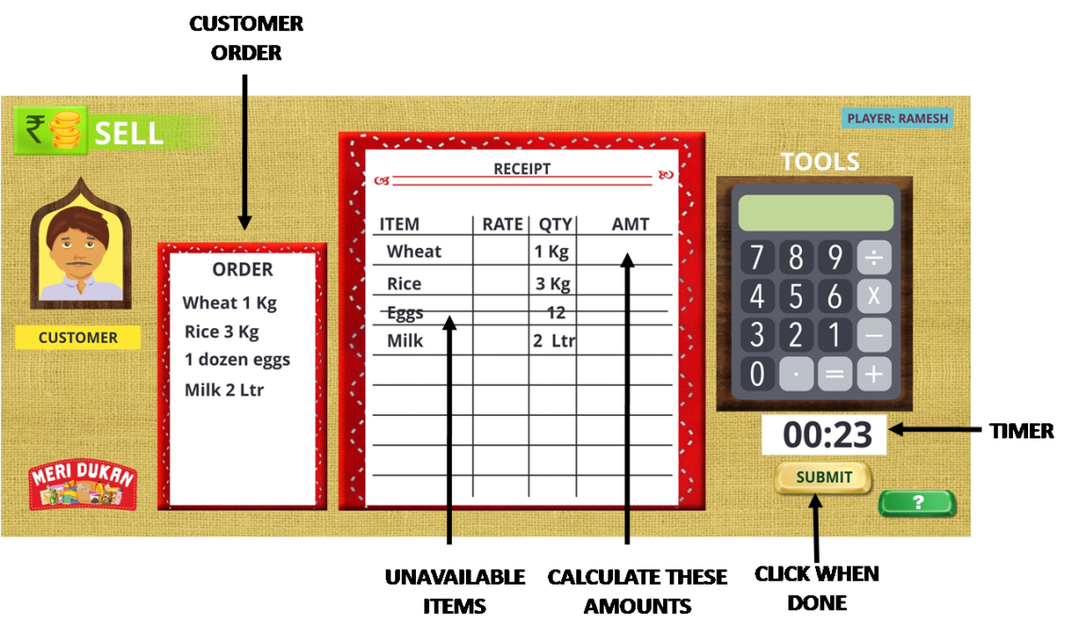

Order: This is the list of items that the customer needs.

Receipt: This list consists of items from the customer’s list that are available in your store. The unavailable items are struck out. ***The lower your inventory level is, the lesser the number of items that will be available.***

The rate and the quantity required are indicated in the columns. You need to calculate the amount that needs to be charged for each item. You can use the calculator for help. Every sales space has a time limit associated with. You earn reputation points if you solve the problem within that time limit. The faster you solve the problem, the higher the number of reputation points you earn.

Click on **Submit** when done.

**Types of Problems and Level of Difficulty**

1. **Very Easy**

These are simple problems that need only addition. The quantities ordered by the customers are unit quantities only.

Example: In the receipt below, rates per kg and L are given and the amounts have to be calculated.

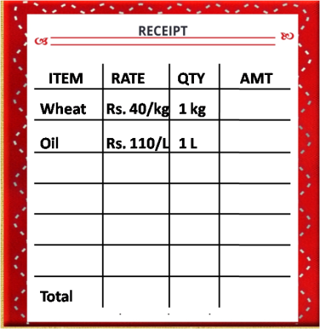

Since only 1 kg of wheat has been ordered, and the rate per kg is Rs. 40, the cost of ordered wheat will be Rs. 40 only.

Since only 1 L of oil has been ordered and the rate per L is Rs. 110, the cost of ordered oil will be Rs. 110 only.

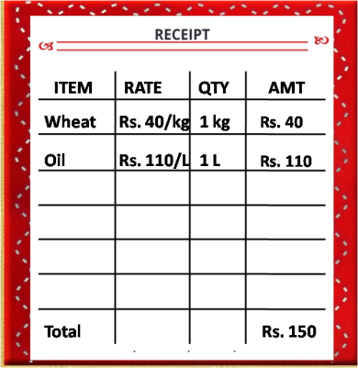

1. **Easy**

These are simple problems that need simple multiplication. The quantities ordered by the customers are multiples of unit quantities.

Example: In the receipt below, rates per kg and L are given and the amounts have to be calculated.

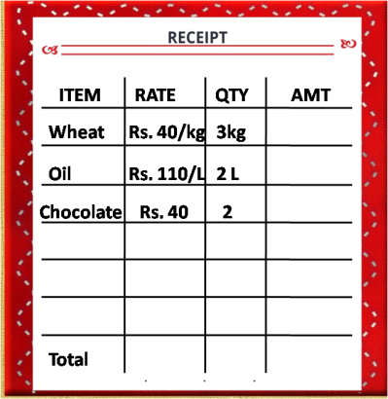

The rate for wheat is Rs. 40 per kg and 3 kg have been ordered. Hence the cost for wheat is:

Rs. 40 + Rs. 40 + Rs.40 = Rs. 40 * 3 = Rs. 120

The rate for oil is Rs. 110 / L and 2L have been ordered. Hence the cost for oil is:

Rs. 110 + Rs. 110 = Rs. 110 * 2 = Rs. 220

The rate for chocolate is Rs. 40 for 1. 2 chocolates have been ordered. Hence the cost of chocolate is:

Rs. 40 + Rs. 40 = Rs. 40 * 2 = Rs. 80

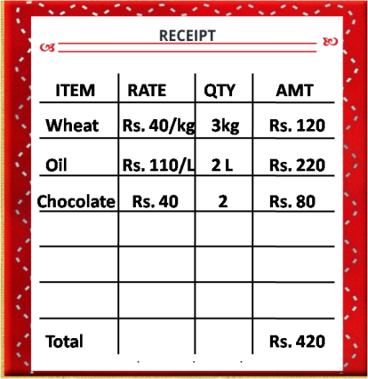

1. **Moderate**

These are simple problems that need simple multiplication. The quantities ordered by the customers are multiples of unit quantities.

Example: In the receipt below, rates per kg and L are given and the amounts have to be calculated.

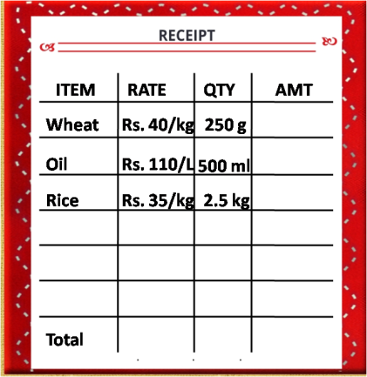

The rate for wheat is Rs. 40 per kg. 250 gm has been ordered.

Since 1000gm = 1Kg, 250 gm = 1/4th kg

Since 250gm = 1/4kg, Cost of 250gm = 1/4th of Rs. 40 = Rs. 10

The rate of oil is Rs. 110 / L. 500 ml has been ordered.

Since 1000 ml = 1 L, 500 m = ½ L

Since 500 ml = ½ L, Cost of 500 ml = ½ of Rs.110 = Rs. 55

2.5 kg Rice = 2kg + ½ kg of Rice

The rate of rice is Rs. 35 per kg.

Therefore 2 kg of Rice will cost Rs. 35 * 2 = Rs.70

And ½ kg of Rice will cost ½ of Rs. 35 = Rs. 17.5

Therefore, 2 ½ kg of rice will cost – Rs. 70 + Rs. 17.5 = Rs. 87.5

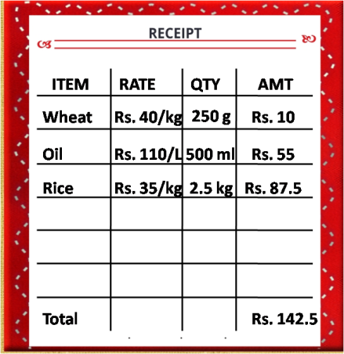

**Purchase**

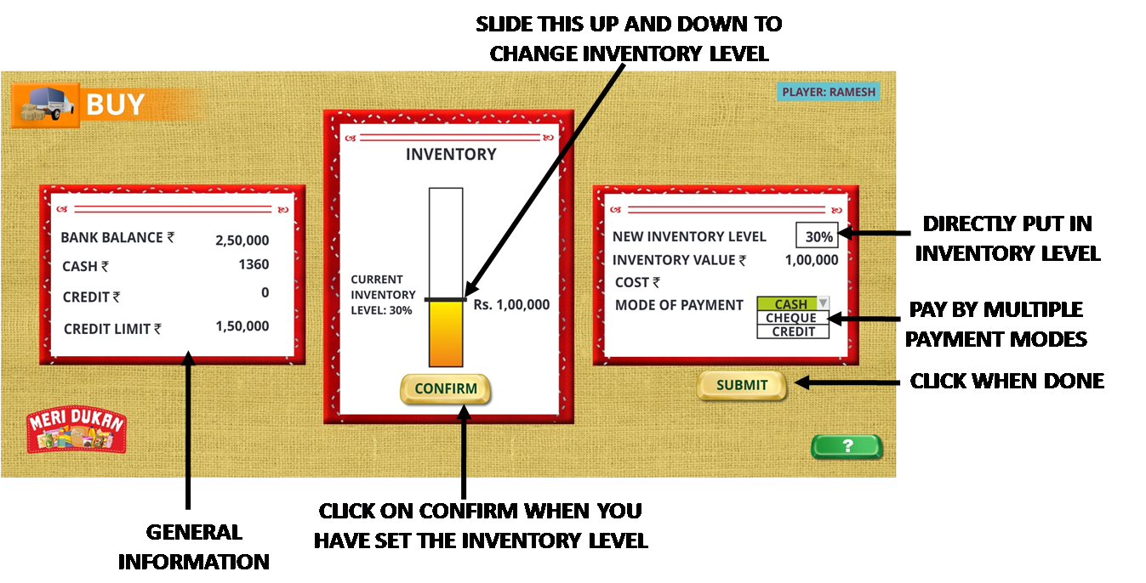

The Purchase or Buy screen is used fill your inventory. If your inventory is not at a high level, items will not be available when ordered by customers.

**Changing Inventory Level:**  Use the slider to change the inventory level and see its corresponding value. When you decide what the level should be click on the ‘Confirm’ button.

**Paying for Purchased Inventory:** You can pay for inventory by three modes.

* Cheque – The amount will be deducted from your bank balance.
* Cash – The amount will be deducted from Cash
* Credit – The amount will be added to your Debt.

You can pay the amount using multiple modes of payment. Eg. If you are purchasing inventory worth Rs. 20000, you can pay Rs. 10000 by cheque and Rs. 10000 on credit.

When you have set the inventory level and defined Payment modes, click on the ‘Submit’ button.

**Decision**

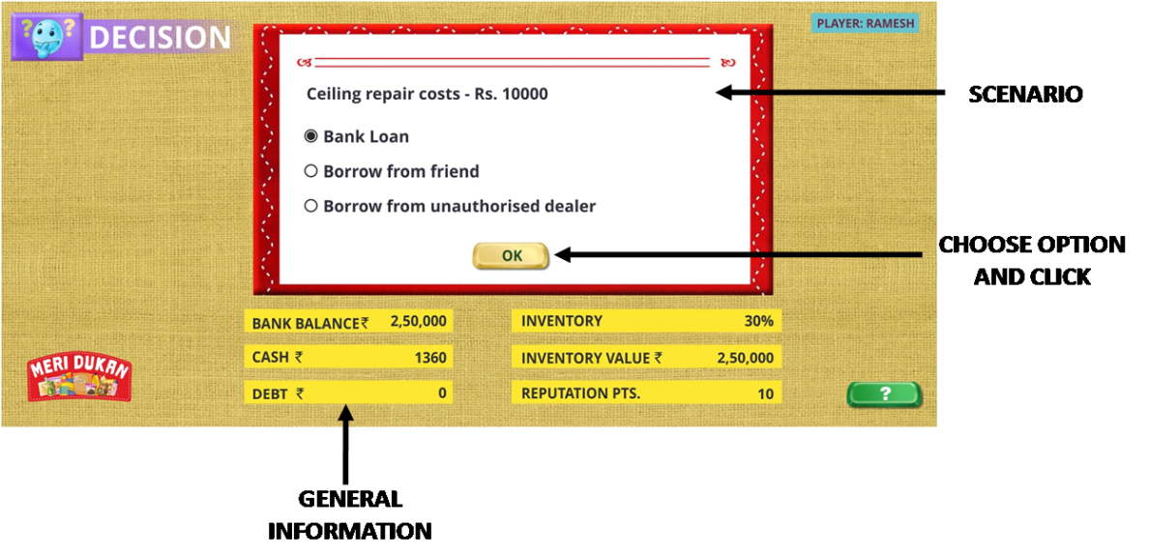

These spaces pose a scenario, where you need to make a decision. For eg., in the above decision, the scenario is that your store’s ceiling needs repair and is going to cost Rs. 10000. The decision is about how you will pay the work?

Each option will make you lose or earn money and/or reputation points. In the example above, taking a bank loan is a safer and better option than borrowing from friends or unauthorized people. Hence this option will earn more reputation points than any of the others.

*<We should add a button that links to subject matter help here>*

**Decision - Insurance**

A special type of Decision may allow you to purchase Insurance. If you decide to purchase insurance you will be directed to another screen that allows you to select the type of insurance, premium and sum assured.

Once you have purchased Insurance, you will not lose money due to natural calamity, theft etc. Therefore, if you were faced with a Bad Luck scenario where you were due to lose money due to these causes, you would not lose it, as you would be covered by Insurance.

**Luck**

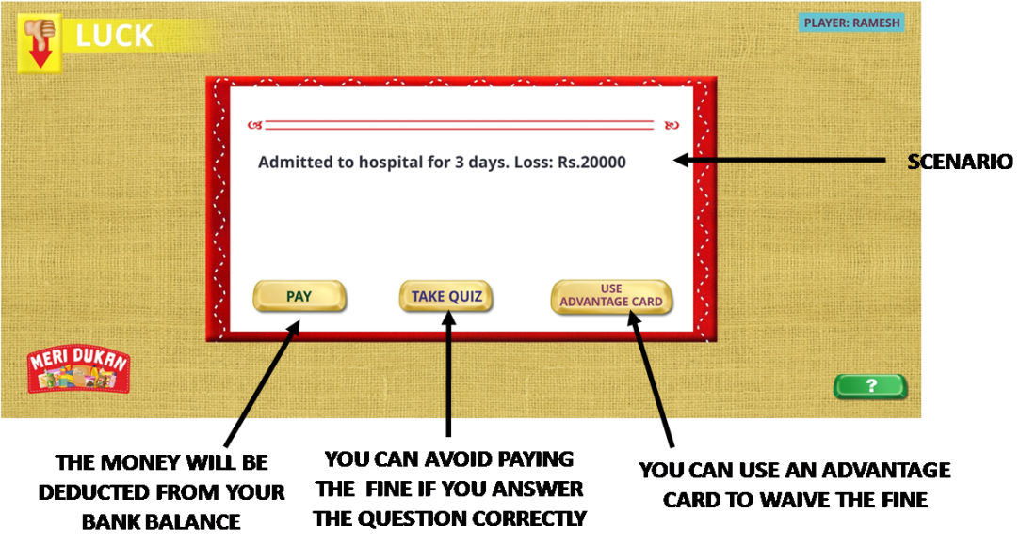

Luck spaces pose lucky or unlucky situations that you face. Lucky situations generally help you earn money or reputation points. Unlucky situations typically cause you to lose money. However, you can avoid losing money if you choose to:

* Answer a question (Take Quiz) – You will be asked a question based on any financial topic. If you can answer it correctly, the fine will be waived.
* Use an Advantage card – If you have one or more advantage cards, you can use one of them to waive the question. Advantage cards can be earned by converting reputation points.

If you click on the ‘Pay’ button, the fine or payment will be deducted from your bank balance.

**Payment**

If you are unlucky enough to land on the Payment space, you will have to pay the fine! It will be deducted from your bank balance!

**Week Up**

This is the space you start the game from. Each time you pass this space, it indicates that one week has elapsed. The following things happen when you pass this space:

1. The cash that has been collected in the past week needs to be deposited in the bank. You will be shown a screen to do the same
2. If four weeks are up since the first time you purchase inventory on credit, you will be reminded to pay off your debt.
3. If 12 weeks are up for you, your accounts will be frozen and you will not get a turn until all players finish.
4. You will also get to see a weekly summary that shows you how the week was

**TOOL TIPS**

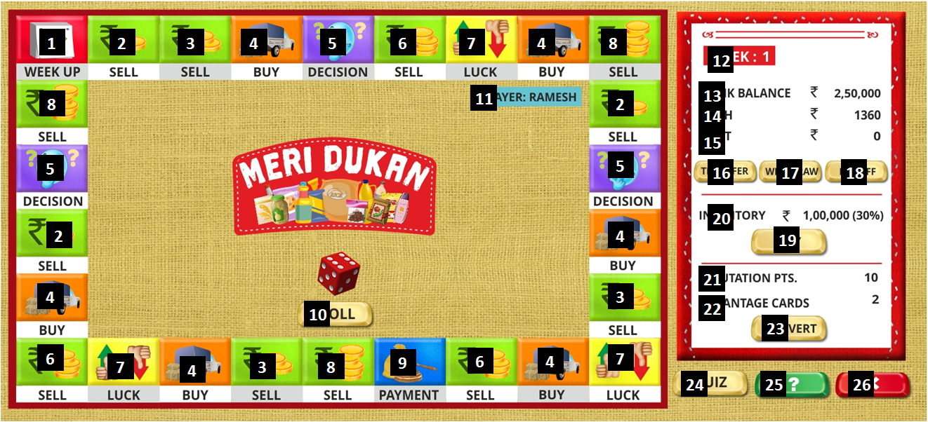

|  |  |
| --- | --- |
| **Number** | **Tool Tip** |
| **1** | **Crossing this means a week is finished** |
| **2** | **Sales space with calculation that is Very Easy** |
| **3** | **Sales space with calculation that is Easy** |
| **4** | **Buy space to purchase inventory** |
| **5** | **Decision space where you will have to choose the best option** |
| **6** | **Sales space with calculation that is Moderate** |
| **7** | **Luck space which may be lucky or unlucky for you** |
| **8** | **Sales space with calculation that is Hard** |
| **9** | **Payment space where you will be charged a fine or penalty** |
| **10** | **Click here to roll the dice on your turn** |
| **11** | **Indicates which player’s turn it is** |
| **12** | **Indicates which week is going on for you** |
| **13** | **Amount of money in your bank account** |
| **14** | **Amount of cash you have in hand** |
| **15** | **Amount you owe after buying inventory on credit** |
| **16** | **Click here to transfer cash to your bank account** |
| **17** | **Click here to withdraw money from your bank account** |
| **18** | **Click here to pay off debt** |
| **19** | **Click here to purchase inventory** |
| **20** | **The current level of your inventory** |
| **21** | **Indicates how many reputation points you have** |
| **22** | **How many advantage cards you have** |
| **23** | **Click here to Convert reputation points to Advantage cards** |
| **24** | **Click here to take a quiz and increase your reputation points** |
| **25** | **Click here for Help** |
| **26** | **Click here to End the Game** |